1.Реализовать **RESTful-edit**:

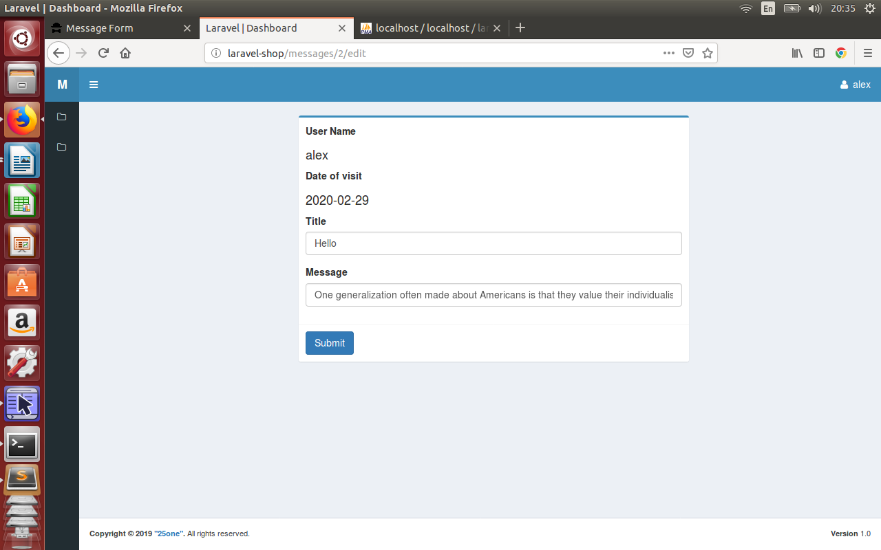

**routes\web.php**

Route::prefix('')->namespace('Front')->group(function () {

...

Route::middleware('auth')->group(function () { //!!!ONLY AUTH-USERS

...

**Route::resource('restmessages', 'MessageController');**

});

**resouces\views\front\messages\restmessages\ → edit.blade.php, create.blade.php, template.blade.php + components (from views\back\messages laravel-message)**

**resouces\views\front\messages\brick-standard.blade.php**

@if($message->user_id == auth()->user()->id)

<td class="center widthbutton"><a class="btn btn-danger listbuttonremove" href="#"><i class="fa fa-trash-o" aria-hidden="true"></i></a></td>

<td class="col-md-6 col-sm-6 col-xs-6 center widthbutton"><a class="btn btn-primary listbuttonupdate" **href="{{route('restmessages.edit', $message->id)}}"**><i class="fa fa-edit" aria-hidden="true"></i></a></td>

**resouces\views\front\messages\restmessages\edit.blade.php**

@extends('front.messages.restmessages.template')

@section('form-open')

<form method="post" action="{{ **route('restmessages.update', [$message->id])** }}">

{{ csrf_field() }}

{{ method_field('PUT') }}

@endsection

**resouces\views\front\messages\restmessages\template.blade.php**

@extends('**front.messages**.layout')

…

@if (session('message-ok'))

@component('**front.messages**.components.alert')

@slot('type')

success

@endslot

{!! session('message-ok') !!}

@endcomponent

@endif

…

**MessageController.php**

use App\ {

Http\Controllers\Controller,

Repositories\MessageRepository**,**

**Models\Apimessage**

};

...

/**

* Show the form for editing the specified resource.

*

* @param \App\Models\Apimessage $message

* @return \Illuminate\Http\Response

*/

public function **edit(Apimessage $restmessage)**

{

**$this->authorize('manage', $restmessage);**

**$message = $restmessage;**

return view(**'front.messages.restmessages.edit', compact('message')**);

}

2.Проверить работу **Policy** (**4 — id message of serg, not alex**):

